0 Introduction
RAG = Retrieval Augmented Generation
→ add extra steps after generation (e.g. looking something up on a website)
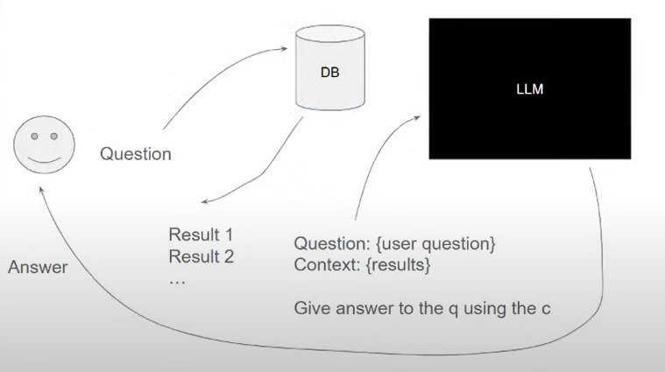
We need the FAQ text in JSON format.
Use parse-faq.ipynb to create JSON (documents.json)

